Municipal Legal Notice Assessment
An Initial Assessment of Legal Requirements, Expenses, and Newspaper Practices
Contents
Introduction 2
Connecticut Statutory Requirements 2
Municipal Publication Expenses 3
The Content of Municipal Legal Notices 5
The Effectiveness of Legal Notice Outreach 6
Initial Recommendations 7
Conclusion 8
Appendices 10

This report was prepared as an initial assessment using working project databases. The underlying spreadsheets remain subject to updates. The Municipal Legal Notice Assessment project databases would not have been possible without the participation and help of membership towns CEOs and department staff; technical support provided by Data Scientist Nicholas Trabka; draft review by the Western Connecticut Council of Governments Deputy Director Michael Towle.

Summer 2026 PICS Internship: Kameil Crane.

Project data collection period. June-August 2026
Municipal Legal Notice Assessment. Report prepared August 2026

Municipal Legal Notice Assessment

Introduction
Municipalities publish legal notices to inform residents about hearings, decisions, meetings, taxation, procurement, and other public actions. WestCOG undertook this assessment in response to municipal concerns about publication expenses and staff workload, and to identify ways to reduce unnecessary costs while maintaining public access and compliance.
This report provides an initial assessment on the practice of municipal legal notices specifically looking at the statutory requirements, cost of doing business, expenses, publication practices, statute requirements, and newspaper circulation in the Western Connecticut Council of Governments (WestCOG) planning region. The municipal expense dataset contains information for all 18 municipalities in the Western Connecticut Planning Region.
The assessment process and the drafting of this report are driven on the following deliverables:
- Municipal Legal Notice Assessment. This report serves as an initial summary of the findings derived from the datasets noted below.
- Statutes and Legal Notice Matrix. An inventory of all Connecticut Statues requiring legal notices and the various terms covered under that statute.
- Municipal Legal Notice Expenditure Table. An inventory of expenses by department and municipality spent on legal notices submitted by municipalities.
- Newspaper Circulation Table. Lists primary newspapers used for legal notices by municipality and their effective circulation and distribution statistics.

Connecticut Statutory Requirements
Connecticut municipalities publish legal notices for a wide range of public actions, including land-use hearings and decisions, town meetings, assessments, procurement, taxation, and other statutory processes. The assessment Connecticut Legal Notice Statute Matrix was designed to identify state requirements and understand what information is legally required to be published in each individual notice.
Connecticut does not apply one uniform publication rule to all municipal legal notices. The assessment identified over 100 Connecticut statutes that require specifically newspaper publication of municipal legal notices. These requirements differ in the information to publish, how far in advance publication must occur, and how often a notice must appear. The town clerk, for example has 18 different statutes to follow for newspaper publications with varying details. Figure 5 (found in Appendix 2) shows the frequency of statutes by department/agency, illustrating that the requirements are distributed across many areas of municipal government rather than being concentrated in one type of activity. This makes standardized publication practices difficult, as a template suitable for one action may not be appropriate for another.
Digital publication and fewer insertions have precedents. Connecticut has already revised selected notice requirements to recognize online publication or reduce newspaper insertions. The statutory review identifies website requirements in several municipal notice provisions. Supplementing newspaper publication with a website posting differs from replacing newspaper publication. Both approaches provide models to examine when considering modernization, but an online posting does not by itself eliminate a newspaper obligation.

Municipal Publication Expenses
This section presents summary statistics and observations regarding municipal noise ordinances across Connecticut.
The assessment was able to review 14 out of 18 municipalities regarding expenses associated with legal notice publications. A table summarizing these expenses is available in Figure 3 in appendix 3. Figure 3 for a table of annual expenses by municipality.
- FY 2023-24 - $254,937.32
- FY 2024-25 - $264,952.68
- FY 2025-26 - $275,909.54
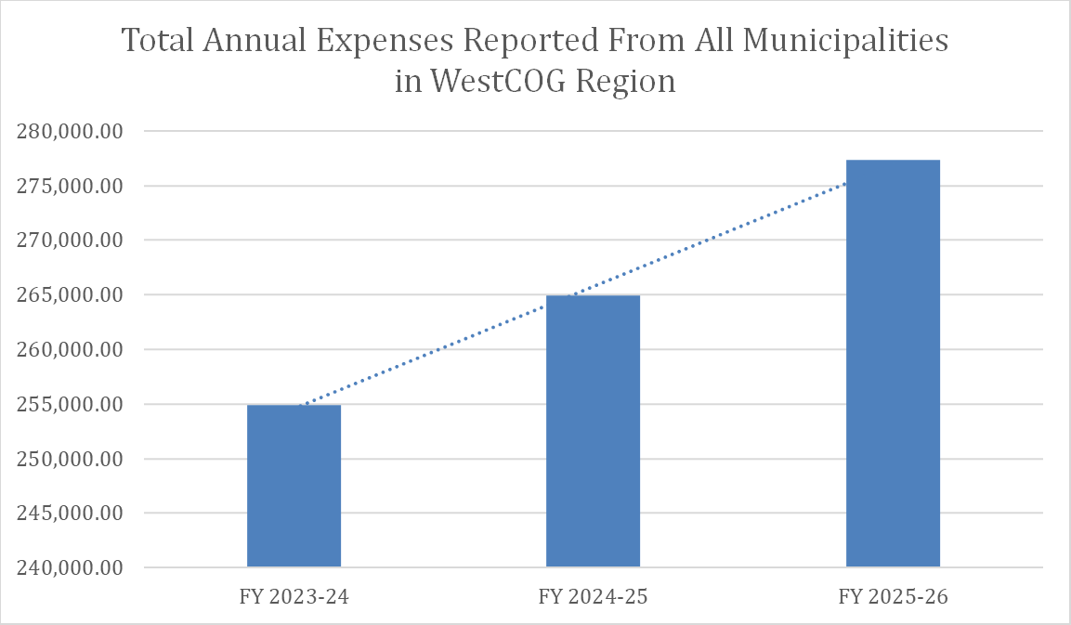
Figure 1. The total annual expenses from all municipalities across three fiscal years. FY 2023-24 exclude Bethel, Bridgewater, Norwalk, and New Milford. FY 2024-25 exclude bethel, Norwalk, and New Milford. FY 2025-26 exclude Norwalk, and New Milford
The FY 2025-26 distribution is uneven. Greenwich has the largest reported expense at $55,351.86, followed by Danbury at $32,260.00, Ridgefield at $25,000.00, Brookfield at $24,355.30, and Newtown at $21,519.30. These five municipalities account for approximately 57% of the reported FY 2025-26 total.

Trends Over Three Fiscal Years
The three-year comparison highlights significant differences in both the level and direction of legal notice expenses across municipalities. Appendix 3, Figure 5, “Annual Expenses Over Three Fiscal Years ($),” shows that legal notice expenses vary substantially among municipalities and follow very different trajectories over the three fiscal years. Greenwich has by far the highest expenses, increasing from approximately $44,000 in FY 2023–24 to $55,000 in FY 2025–26, despite a decline in FY 2024–25. Danbury also shows a consistent increase, rising from approximately $22,000 to $32,000 over the three-year period. In contrast, Brookfield and Ridgefield both peaked around $30,000 in FY 2024–25 before declining in FY 2025–26, while Stamford, Westport, and Wilton remained relatively stable across the three years. The remaining municipalities generally have lower expenses, and several show downward trends, particularly Newtown, Redding, New Fairfield, and Weston.
Overall, legal notice expenses do not follow a uniform regional trend; spending varies considerably by municipality, with some towns experiencing sustained increases, others remaining relatively stable, and others declining. The variable of charter revisions should also be noted. However, only Brookfield reported a charter revision/ordinance update, occurring in FY 2024-25.
Department-Level Expenses
Legal notice costs are concentrated in a relatively small number of municipal functions. Figure 6 in Appendix 3, illustrates these differences and shows that land-use-related notices represent the largest identifiable source of departmental legal notice spending. On average, the major departments accounted for the following shares of each municipality’s total legal notice expenses:
- Land Use – 37.4%
- Miscellaneous – 22.5%
- Selectmen’s office – 14.8%
- Town Clerk – 13.6%
- Purchasing Department – 6.7%
- Tax Collector – 3.8%
- Assessor – 1.2%
The data also reveal an important limitation in comparing municipal totals with department-reported expenses. In several municipalities, the sum of the expenses reported by individual departments is greater than the municipality's reported total annual legal notice expense. For example, Bridgewater's departmental expenses total approximately $7,003 compared with a reported municipal total of $4,088; Brookfield's departmental expenses total approximately $27,735 compared with $24,355 reported for the municipality; and the difference is particularly large in Westport ($23,014 department-reported compared with $11,400 municipality-reported). These discrepancies indicate that the department-level data should be interpreted as a breakdown of reported expenses rather than a perfectly reconciled account of total municipal spending. They may reflect differences in how municipalities categorize expenses, reporting periods, or which accounts are included in their overall totals.

The Content of Municipal Legal Notices
This section presents summary statistics and observations regarding legal notices and their contents published by the member municipalities.

Overview
As of now, 636 legal notice records from 13 municipalities have been assessed to varying degrees. There are 610 records containing a recorded publication cost, totaling approximately $122,274. The database currently includes 283 notices with recorded word counts, ranging from 38 to 2,000 words. Refer to Figure 7, found in Appendix 4, a scatter plot analysis for legal notice costs relative to their length.
The data show a clear positive relationship between notice length and publication cost. The scatter plot contains 271 points, and its trendline illustrates this relationship. The analysis estimates that, within this sample, each additional 100 words is associated with approximately $34 in additional publication cost on average. The relationship is not exact because newspaper rates, publication frequency, formatting, and other factors also affect this cost. It is important to note that every sale of a legal notice comes at a different rate. What determines the rate is still unknown, and this factor has only been identified to apply to Hearst Media products so far.
The database also demonstrates that publication frequency can substantially increase costs. Although twice-published notices represent only about 15% of records, they account for approximately $28,952 in recorded costs, compared with $92,848 for once-published notices.

Common Sources of Excessive Legal Notice Length
The content review identified several types of information that can contribute to unnecessarily lengthy legal notices:
- Detailed project description. Lengthy explanations of a proposed development, construction project, zoning change, or other action that go beyond identifying the project and the action being considered.
- Extensive property descriptions. Lengthy descriptions of property characteristics, existing conditions, proposed improvements, or surrounding properties when a property address, parcel identification, or other required identifier may sufficiently identify the location.
- Repeated procedural language. Standard phrases explaining the hearing or decision process that appear repeatedly across notices and may be capable of being standardized into a shorter template.
- Excessive background information. Descriptions of the history of an application, previous hearings, prior decisions, or earlier versions of a proposal that may not be necessary to inform the public of the current action.

The Effectiveness of Legal Notice Outreach
This section presents summary statistics and observations regarding newspapers used by the municipalities.

Overview
The WestCOG newspaper database currently identifies a primary newspaper for all 18 municipalities in the regional study area. Twelve municipalities are associated with a corporate parent, Hearst Media, while six are associated with independent local ownership. Most municipalities have more than one identified newspaper option in the database. Refer to Appendix 5 for Figure 8, a primary newspaper database that includes rate structure. Along with Figure 9, a map of the primary newspapers used by the Western Connecticut Council of Governments planning region.
Circulation information is uneven across newspapers. Some records contain audited or reported print circulation, while others do not yet have a verified circulation value. However, from the reported circulation numbers of both primary and secondary newspapers, all towns fall below 7% of total households subscribed. Refer to Appendix 5, for Figure 10, A map of the household print circulation rate.

Newspaper Subscriptions
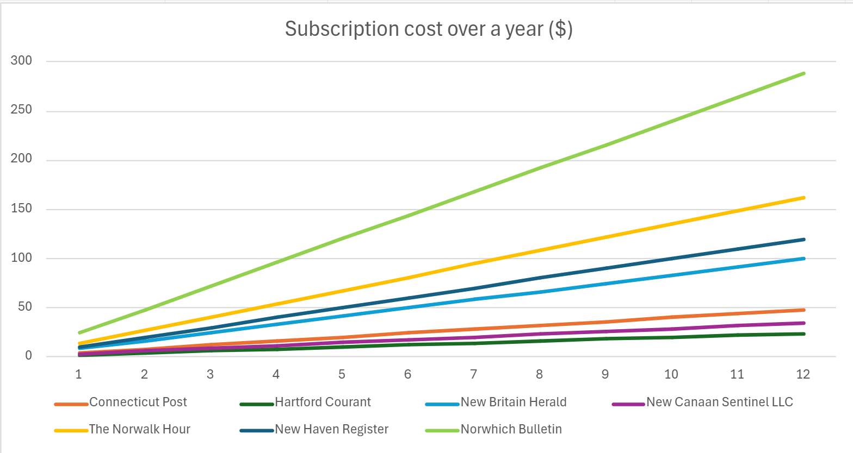
Figure 2. Subscription trendlines of common newspapers across Connecticut.
Newspaper subscription prices illustrate a potential barrier in the current legal notice system: the cost of accessing the publication in which public notices appear. The assessment newspaper database includes subscription information for several publications. A sample group containing costs estimated over a year for a weekly print subscription are seen in Figure 2. The highest cost is slightly below $300, while the lowest cost is around $35. The average cost for a Hearst Media newspaper is around $160, represented by The Norwalk Hour. While municipalities pay to place notices in newspapers, residents may also face a separate cost if they want consistent access to the newspaper through a paid print or digital subscription.

Initial Recommendations
The data collected suggest that municipalities can reduce the financial and administrative burden of legal notices without waiting for statewide statutory changes. The following recommendations are intended as short-term actions that municipalities can implement within existing publication requirements. Any changes to notice language or publication practices should first be checked against the applicable statute, because Connecticut's requirements differ by notice type, including requirements for frequency, timing, content, and newspaper circulation. The Connecticut General Assembly's 2026 Office of Legislative Research report provides a useful starting point for identifying these requirements.
- Centralize Legal Notice Expense Tracking. The current project found that municipal expense records can be fragmented and, in some cases, do not reconcile with the expenses reported separately by individual departments. A centralized tracking system would provide a more accurate picture of total municipal spending and make it easier to identify which departments, and notice types, generate the greatest costs. The Greenwich record sheet provides a useful model for maintaining detailed legal notice expense information across departments. A standardized municipal tracking system would also allow staff to compare expenses from year to year and identify opportunities for cost reduction.

- Create Standardized Legal Notice Templates. Standardized templates could help reduce the amount of newspaper space used by eliminating repetitive language and unnecessary explanatory material. When legally permissible, municipalities should consider using the newspaper notice as a concise announcement while maintaining the complete notice and supporting materials online.

A shortened newspaper notice could identify:
- The municipality or agency
- Type of action
- Date, time, and location
- Application, project, or case number
- Property or project identification
- Other information specifically required by statute
- Where the complete notice and supporting materials can be accessed

The complete record could then be maintained on the municipal website and include applications, maps, plans, staff reports, technical documents, and other support information.

- Combine Notices When Legally Permitted. When multiple notices have similar publication dates and newspaper requirements, municipalities should determine whether they can legally be combined into a single advertisement. Combining notices may reduce the amount of newspaper space purchased and eliminate duplicate publication costs.

- Maintain a Searchable Digital Archive. Municipalities can maintain a centralized searchable online archive that spans all departments. A digital archive would make it easier for residents to locate notices after publication and would provide municipal staff with a permanent record of published notices. It could also reduce the need for staff to repeatedly locate older newspaper publications when responding to public inquiries or records requests.

Conclusion
This project demonstrates that Connecticut’s current legal notice system creates a measurable financial and administrative burden for municipalities, with costs influenced by notice length, publication frequency, newspaper rates, and the number of departments responsible for publishing notices. The data also show that municipal practices and recordkeeping vary considerably, making it difficult to consistently evaluate expenses or identify opportunities for savings. At the same time, the statute and content reviews indicate that some notices may contain opportunities for greater standardization and more efficient use of newspaper space.
The findings support a two-part approach to modernization: municipalities can pursue short-term improvements through centralized expense tracking, standardized templates, and careful review of notice content, while the state considers longer-term changes to publication requirements. Future work should expand the database to include additional municipalities, complete missing expense and notice information, and conduct a statute-by-statute review of high-cost and high-frequency notices. This expanded dataset could then be used to develop specific legislative recommendations for maintaining public access and transparency while reducing unnecessary publication costs and administrative burden.

Appendices

A1 – Methodology and Data Limitations
Municipal Legal Notice Expenditure Table. The assessment uses the spreadsheet ‘Compiled Data from Legal Notice Assessment’ for expense and newspaper publication data. The data was collected from the individual municipalities from invoices, town records, and budgets.
Legal Notice Statute Matrix. The assessment uses the Excel file ‘Connecticut Legal Notice Statute Matrix’. This matrix was created by reviewing Connecticut’s complete statute list. The search was conducted by searching for words: publish, print, public notice, and newspaper. Identified statutes were scanned for the appropriate data. Data revision was conducted afterwards, removing statutes that targeted certain parties instead of the entire municipality; along with removing statutes where the municipality was not publishing the notice. The assessment statute classifications are treated as project research outputs. They are not presented as legal advice. The OLR’s 2026-R-0033 report provides an external statewide reference point and identifies 154 newspaper-publication statutes using its own methodology. [OLR 2026-R-0033]
Municipal Legal Notice Content Table. The assessment uses the spreadsheet ‘Legal Notice Database’. The database was analyzed using records from member municipalities, such as bills, word documents, newspaper excerpts, invoices, and proofs. Cost statistics use only records with a numeric cost.
Newspaper Circulation Table. The assessment uses the spreadsheet ‘Newspaper Assessment 2026'. Primary newspapers were identified by either the municipality, online legal-notice-search databases, or AI with links. Newspaper websites were referred to for subscription cost. Auditing source AAM (Alliance for Audited Media) was used as a source for collecting circulation numbers. Newspaper ownership, circulation, rate, and subscription fields are treated as reported assessment data and are not assumed to be complete where cells are blank.
Optimization analysis. Recorded optimization percentages are treated as project estimates. Optimization estimates were conducted using AI. The input contained the original notice, the statute associated, and a direction to reduce the notice following the language of the statute. These suggestions do not account for individual town charters or any other outside factors. The illustrative savings calculation applies those percentages to recorded costs only; it is not a projection of actual future savings.

A2 - The Review of Statutes Requiring Legal Notice Publication
Historical Context
In its April 2026 update to the 2016 report, the Connecticut General Assembly’s Office of Legislative Research (OLR) identified 154 statutes requiring municipalities to publish legal notices in newspapers. The Connecticut Legal Notice Statute Matrix used in this assessment applies a separate screening and classification process and should not be treated as directly comparable to the OLR count. [OLR 2026-R-0033]
Connecticut has also considered alternatives to full-length newspaper publication. In 2013, SSB 1112 proposed allowing abbreviated legal notices for specified municipal notices, including notices under CGS § 7-3, provided specified information remained available to the public. This provides an important historical precedent for considering notice-length optimization. [CGA 2013]
Most recently, HB 5289 in the 2026 legislative session proposed replacing many newspaper publication requirements with conspicuous posting on municipal websites while permitting municipalities to continue newspaper publication. The House passed the bill as amended on April 9, 2026; the Senate later recommitted it to the Planning and Development Committee on April 23. The bill did not advance to enactment during the 2026 session. [CGA HB 5289]

The Connecticut Legal Notice Statute Matrix
The assessment, Connecticut Legal Notice Statute Matrix, is intended to identify the legal provisions that generate newspaper publication requirements and to connect those provisions to observed notices.
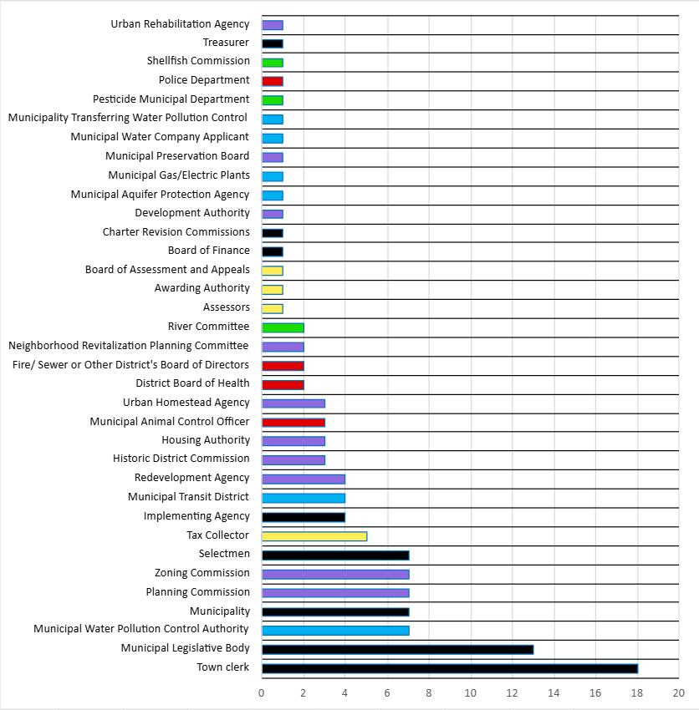
Figure 3. The frequency of statutes per department/agency.
The graph above is color coded by:
- Red – Public health & safety
- Yellow – Finance & taxation
- Green – Environmental & natural resources
- Blue – Utilities & public work
- Purple – Land use & development
- Black – General municipal government

Evidence That Publication Requirements Can Be Modernized
Importantly, the statute review identified evidence that Connecticut has already amended individual statutes to incorporate digital publication or reduce traditional newspaper requirements. These amendments demonstrate that newspaper publication is not necessarily an immutable component of Connecticut's public-notice system. For example, CGS § 9-225 and § 9-226 have been amended to add Internet website posting requirements for election notices. Similarly, CGS § 7-255(a) was amended to require publication of certain pollution control hearing and charge information on a municipal Internet website, and CGS § 8-127(b) was amended to add a website-posting requirement for redevelopment-plan notices. CGS § 22-332(a) provides another example in which Internet posting was added in addition to newspaper publication.
The analysis also identified amendments that have reduced the burden of newspaper publication itself. For example, CGS § 7-147e(a) was amended to reduce the required number of newspaper publications for certain historic-district notices from seven to two. It demonstrates that the legislature has previously recognized that the frequency of newspaper publication can be modified without eliminating the underlying public-notice requirement.
A particularly important example appears outside the project's 119-statute newspaper subset in the broader public-notice statute database. CGS § 4b-34(a) was amended by Public Act 25-168 to replace a newspaper advertising requirement with publication on the department's Internet website. This is a recent example of Connecticut legislation directly transitioning a public-notice requirement away from newspaper advertising and toward government-controlled digital publication. The example is relevant because it demonstrates that Connecticut has already begun implementing a type of publication modernization.
The statute data suggests several potential avenues for reform. Requirements that currently require multiple newspaper publications could be reviewed for whether the number of required publications remains necessary. Statutes that already recognize municipal websites as an appropriate source of public information could provide models for expanding digital publication. Requirements could also distinguish between the legally essential information that must be publicly announced and supplemental information that could be made available through a municipal website, reducing the amount of expensive newspaper space required. A statutory framework that allows a concise newspaper notice to direct residents to a complete municipal website posting could potentially preserve transparency while reducing the amount of paid newspaper space. The statute analysis provides a policy foundation for the assessment’s broader examination of notice content, newspaper expenses, and opportunities for modernization.

A3 – Expense Trends and Municipal Data
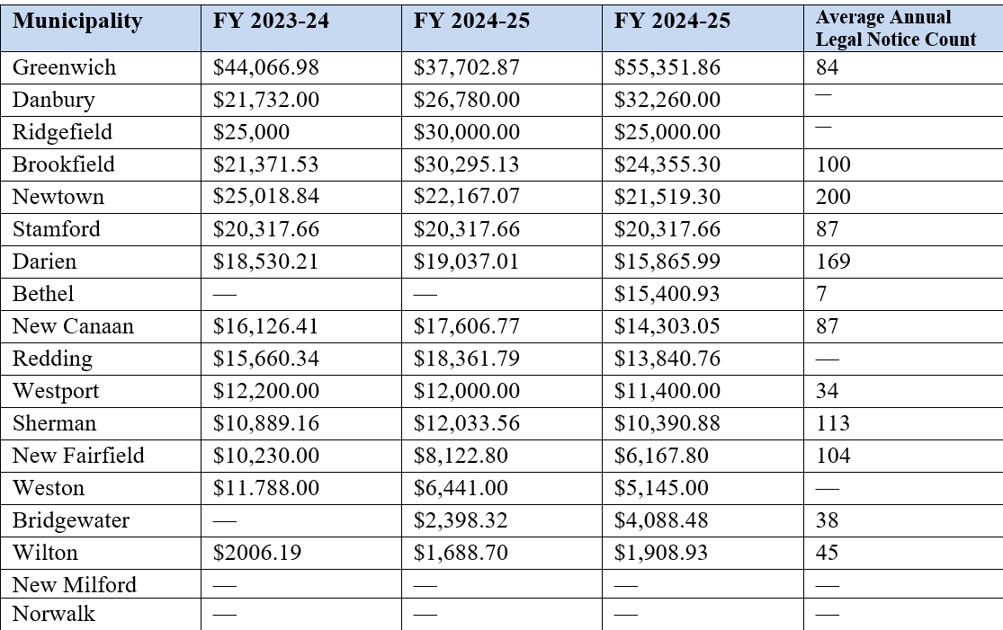
Figure 4. Table of municipality annual expenses across three fiscal years and the average number of legal notices per year. Missing values indicate that a value was not present in the uploaded spreadsheet.
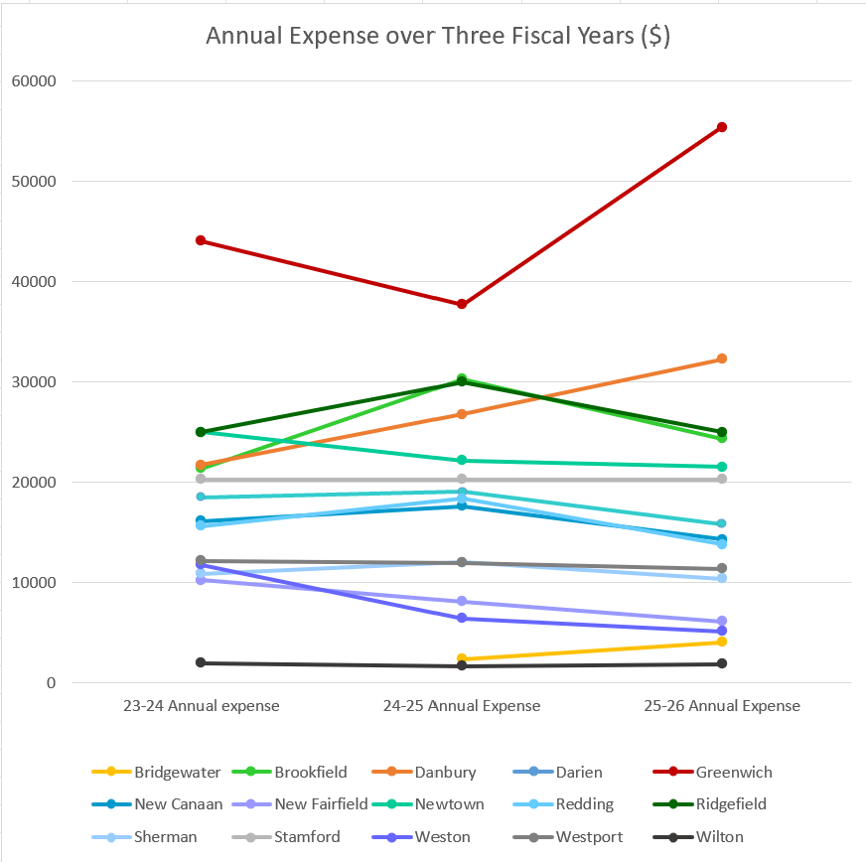
Figure 5. A visual representation of individual towns annual expenses across three fiscal years.
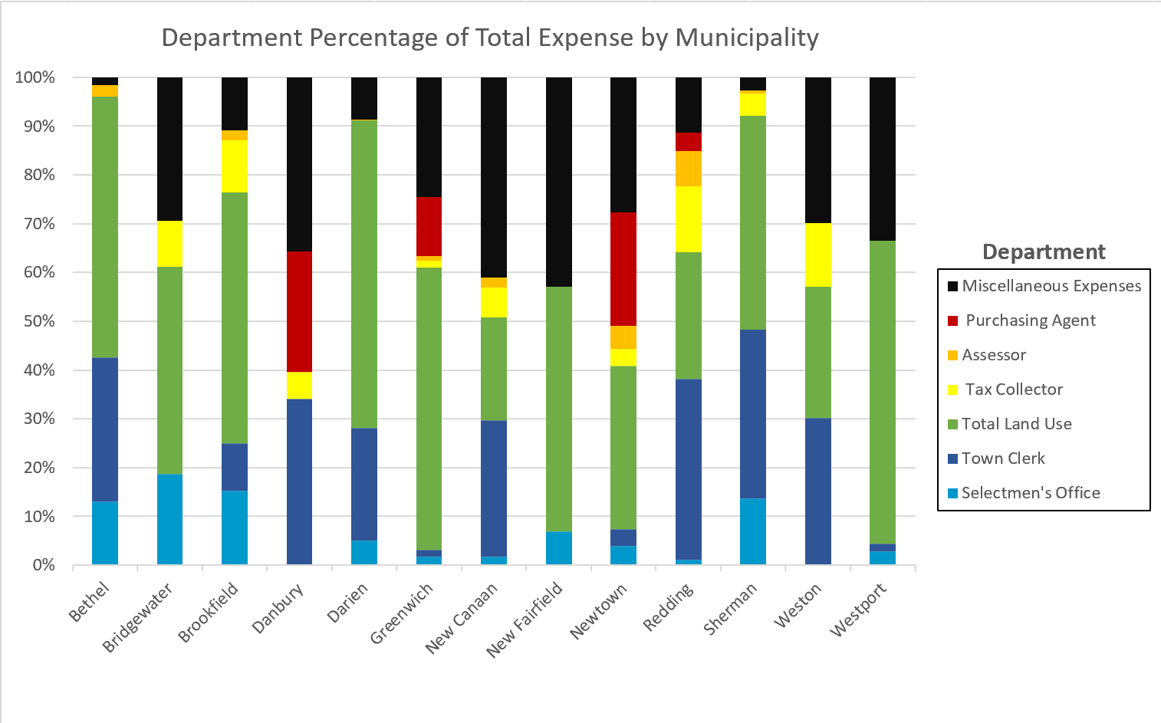
Figure 6. Department percentage of total expenses reported by individually from FY 2025-26. Norwalk, New Milford, Ridgefield, and Stamford are not shown due to lack of data.
The department data provides a more detailed picture of legal notice spending than the municipality-wide annual totals alone. Of the identifiable departmental categories, Total Land Use is the largest expense category, representing 37.4% of the department-level expenses in the current dataset. This category combines land-use-related functions and therefore represents an important area for further analysis. Planning and zoning activities frequently generate legally required public notices, including hearings, decisions, applications, and other land-use actions. The concentration of spending in this category is consistent with the assessment's broader statute and notice analysis, which found that land-use requirements account for a substantial share of the legal notices' activity being examined.
The Miscellaneous category represents another 22.5% of reported department-level expenses. This is a particularly important category to investigate because it represents a substantial amount of spending that cannot currently be attributed to one of the major departmental categories. Depending on how individual municipalities classified these expenses, the category may contain notices from multiple offices or notices that were not assigned to a specific department. A few municipalities were able to identify all costs and the associated department. Only Greenwich had a complete record of all public legal notices. Because of its size, further analysis of the miscellaneous category could substantially improve the project's ability to identify which types of notices are driving costs.

Discrepancies in Reported Expenses
One of the most interesting findings from this dataset is that municipality-wide reported expenses and department-level reported expenses do not always agree. This is not necessarily an error in the data. Rather, it demonstrates one of the challenges of collecting municipal legal notice information: municipalities do not necessarily organize or report legal notice expenses in the same way.
These differences are significant because they demonstrate that a statewide assessment based solely on municipality-wide accounting totals could underestimate or otherwise misrepresent where legal notice money is being spent. Conversely, simply adding departmental figures may overstate total municipal spending if some categories overlap or are accounted for differently. There are also municipalities for which a municipality-wide FY 2025–26 total is currently unavailable while department-level information is present (Norwalk and New Milford are not shown on Figure 8 for this reason).

A4 – A Review of the Legal Notice Database
The Legal Notice Database records information for each individual notice, including the municipality, department, statute cited, whether the notice is required by state law, notice content, publication date, newspaper, publication frequency, newspaper rate structure, cost, notice length, and an assessment of opportunities to reduce the notice's length or cost. It also includes comments explaining why a particular notice was considered capable of being shortened.
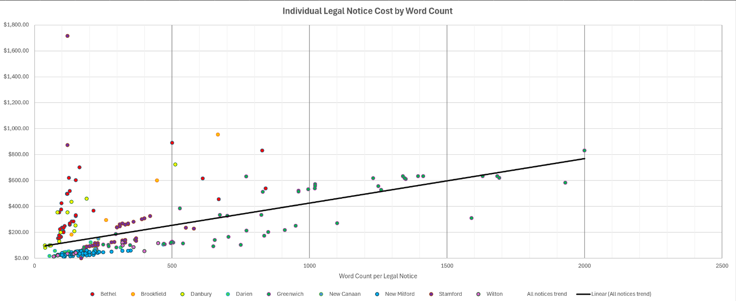
Figure 7. Legal notices by cost and word count.
The scatter plot, Figure 9, illustrates the relationship between notice length and cost. Each point represents an individual notice, with word count on the x-axis and publication cost on the y-axis. The points are color-coded by municipality, allowing differences between municipalities to be observed while also showing the overall trend. The trendline slopes upward, indicating that longer notices generally cost more to publish.
The distribution of average notice length is as follows:
- 46 notices are 100 words or fewer.
- 109 notices are between 101 and 200 words.
- 43 notices are between 201 and 300 words.
- 39 notices are between 301 and 500 words.
- 28 notices are between 501 and 1,000 words.
- 18 notices exceed 1,000 words.
The average recorded cost for notices between 101 and 200 words is approximately $148, while notices between 501 and 1,000 words average approximately $374. Notices exceeding 1,000 words on average are approximately $577.
One of the longest notices in the dataset is a 2,000-word Greenwich Planning & Zoning notice that cost $831.82 and was published twice. Other long Greenwich Planning & Zoning notices include a 1,690-word notice costing $619.46 and a 1,930-word notice costing $582.38. These examples demonstrate how lengthy notices can become significant individual expenditures, especially if they must be published twice.

In Depth Explanation of the Opportunities for Optimization Field
One of the most valuable parts of the database is the Opportunity for Optimization field. This field represents the project's assessment of how much of a notice could potentially be shortened while retaining the information necessary for the public to understand the action being announced.
Across all 79 records with a numerical optimization percentage, the average estimated opportunity reduction is approximately 35%. The estimated range extends from 0% to 70%. These percentages should be presented as project estimates rather than confirmed savings, because they represent an assessment of potentially unnecessary or compressible content rather than actual costs that would be saved under a revised statute.
The highest-rated examples are particularly useful for demonstrating potential impacts. Several Greenwich Planning & Zoning notices contain hundreds or more than 1,000 words and were assessed as having 60–70% optimization potential. For example, a 1,020-word Greenwich Planning & Zoning notice costing $572.08 was assessed at 65% potential optimization, while a 1,690-word notice costing $619.46 was assessed at 64%.
The comments explain what driving potential reductions are. Common examples include repetitive language, lengthy descriptions of development projects, detailed engineering or site information, extensive regulatory citations, third-party names and descriptions, individual project-component lists, and information that may already exist in the administrative record.

A5 – A Review of the Newspaper Directory and Municipality Coverage
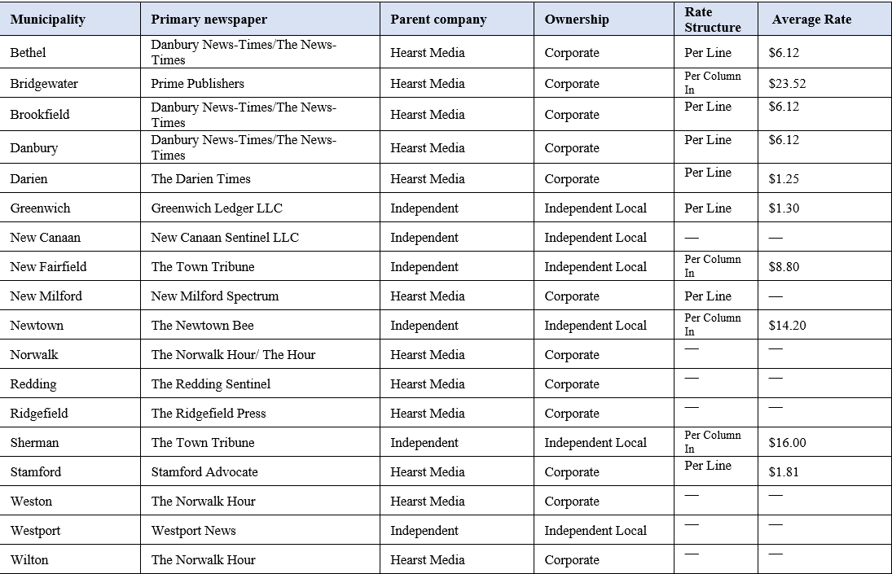
Figure 8. A primary newspaper database of the Western Connecticut Planning Region municipalities.
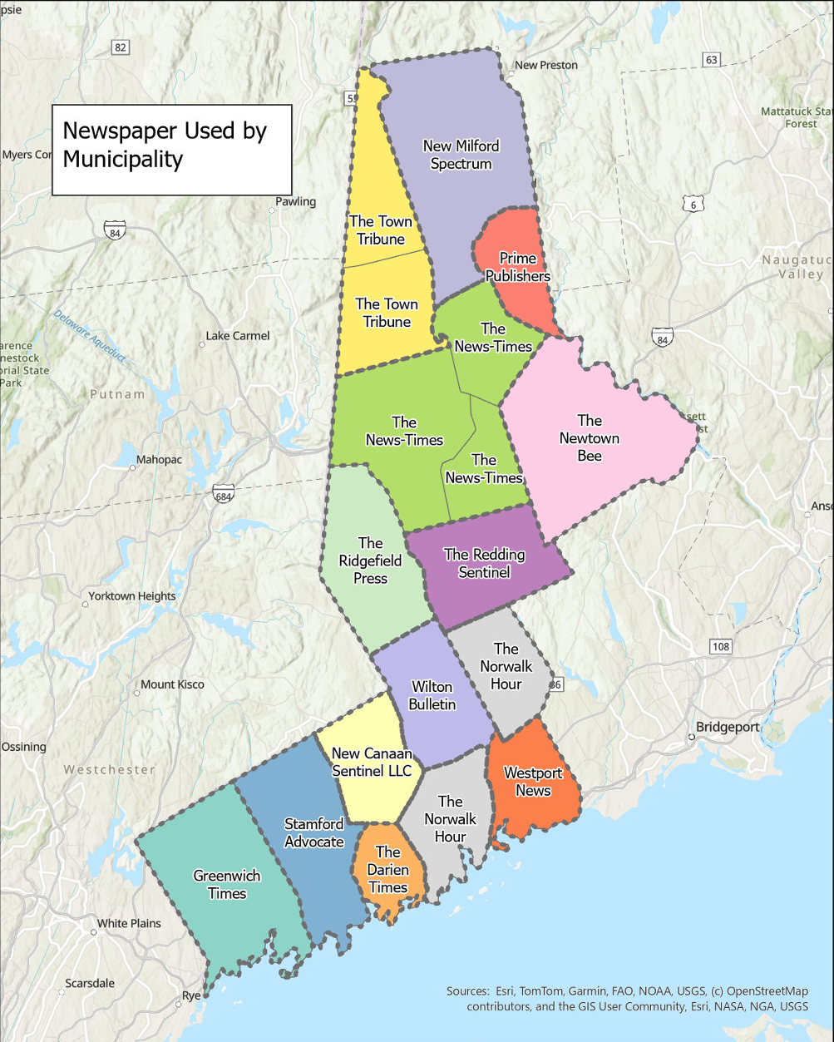
Figure 9. A map of the primary newspapers used by the Western Connecticut Council of Governments planning region. Note – Danbury News-Times is referred to as The News-Times.

A Concentrated Newspaper Market
The statewide database indicates that Connecticut's municipal legal notice system operates within a relatively concentrated newspaper market. Of the 169 municipalities, 116 are associated with a corporate-owned primary newspaper, compared with 53 associated with independent regional or local newspapers. This means that roughly seven out of every ten municipalities in the database primarily rely on a corporate-owned publication.
Concentration becomes more apparent when examining parent companies. Hearst Media accounts for the primary newspaper associated with 88 municipalities, or approximately 52% of the statewide database. Alden Global Capital, Gannett, The Day Publishing Company, and Chronicle Media LLC account for additional municipalities. This concentration is important because changes in newspaper ownership, pricing structures, or publication practices by a relatively small number of companies could affect a substantial portion of Connecticut municipalities. There is already a precedent for Hearst Media buying smaller independent newspapers. If, on average, independent newspapers charge less for legal notices, then it can be inferred that expenses will continue to increase as more local newspapers are bought.

Circulation rates of Newspapers
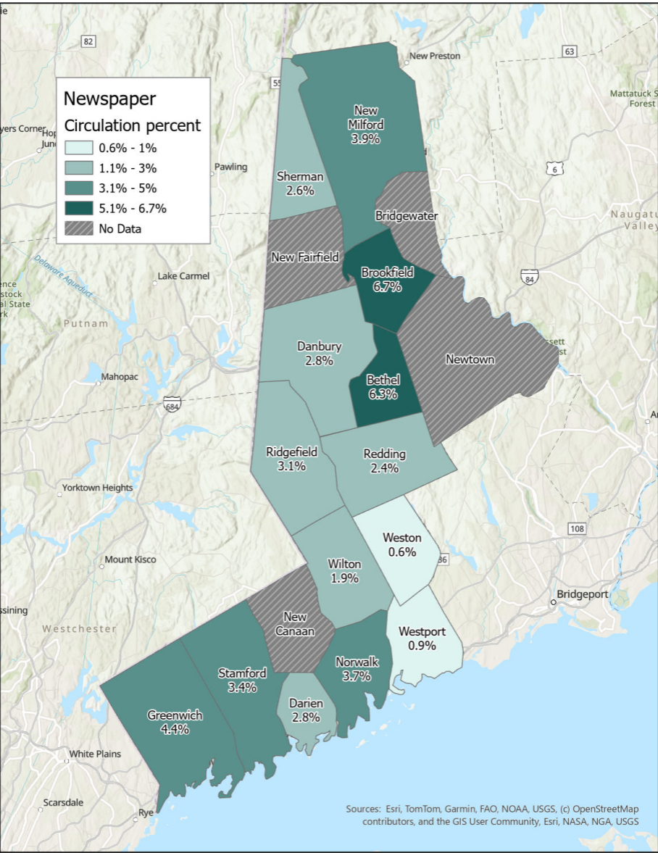
Figure 10. A map of the household print circulation rate in the Wester Connecticut Council of Governments planning region.
Due to lack of primary circulation data. The map shows the available data for both primary and secondary newspapers. Newspaper circulation rates are shown as:
- Bethel – Primary Newspaper
- Bridgewater – N/A
- Brookfield – Primary Newspaper
- Danbury – Primary Newspaper
- Darien – Secondary Newspaper
- Greenwich – Secondary Newspaper
- New Canaan – N/A
- New Fairfield – N/A
- New Milford – Secondary Newspaper
- Newtown – N/A
- Norwalk – Primary Newspaper
- Redding – Secondary Newspaper
- Ridgefield – Secondary Newspaper
- Sherman – Secondary Newspaper
- Stamford – Primary Newspaper
- Weston – Primary Newspaper
- Westport – Secondary Newspaper
- Wilton – Secondary Newspaper
Only a portion of the newspaper directory has been audited for circulation numbers, identified by Alliance for Audited Media (AAM). It is recommended to audit the remaining municipalities to complete the data set.
A6 – Looking ahead
The findings in this report support a potential legislative approach that preserves public notice while giving municipalities greater flexibility in how notice is provided. Rather than treating newspaper publication as the default for every type of notice, legislation could distinguish between notices that require broad public advertising and those for which a municipal website, statewide public-notice portal, or other digital platform could provide equal or greater accessibility.
If Connecticut changed its legal notice requirements, where would the greatest financial impact occur? The answer from the current data appears to be land-use-related notices first, followed by Selectmen's Office notices, and Town Clerk notices. This is important because legislative reform does not necessarily need to treat every legal notice requirement identically. The legislature could prioritize statutory requirements that generate high-frequency or high-cost publication activity.
Repeated publication is particularly important because changing a requirement from multiple newspaper publications to one newspaper notice supplemented by digital publication could produce recurring savings. Furthermore, if the notices became digital on a centralized website, then a subscription-based notification system could present an alternative solution to reoccurring notices. This could also lessen the labor from municipalities, where staff must estimate when notices should be re-run to comply with statute frequency requirements.
There is another solution when turning towards digital platforms which could still support newspapers to some degree. This solution arises with the concern for lack of financial support for local newspapers. If municipalities were permitted to publish the full notice on an official municipal website or a centralized statewide portal, newspaper advertisements could be shortened to a standardized announcement containing the essential information, publication date, and a location where the complete notice could be accessed.

A7 – References
Alliance for Audited Media. (2026). Alliance for Audited Media. https://auditedmedia.com/
Connecticut General Assembly, Office of Legislative Research. Municipal Legal Notice Requirements, 2026-R-0033, April 17, 2026.
Connecticut General Assembly. HB 5289, An Act Concerning the Publication of Municipal Legal Notices, 2026 Regular Session.
Connecticut General Assembly, Office of Legislative Research. An Act Concerning the Publication of Legal Notices by Municipalities, SSB 1112, 2013.
Connecticut General Assembly, Office of Legislative Research. Municipal Legal Notice Requirements, 2016-R-0099, 2016.
Western Connecticut Planning Region working datasets: Legal Notice Database (Legal Notice Database); Compiled Data from Legal Notice Assessment; Legal Notice Statute Matrix (Newspaper required statutes); Legal Notice Statute Matrix (Notes); Newspaper Assessment (WestCOG Database); Newspaper Assessment (Newspaper Directory); Newspaper Assessment (Municipality Newspaper Database).

